Assignment: Predicting future outcomes

Turtle Games
Faye Grant
April 2026

Contents

- Background/context of the business

- Analytical approach

  - Python
  - R Studio

- Visualisation and insights

- Patterns and predictions

- Appendices

- Background/context of the business

Turtle Games is a global game manufacturer and retailer which sells both own brand and external products including books, board games, video games and toys. The company collects data from sales and customer reviews. The objective for the data analytics team is to use this data to improve overall sales performance. The analysis focusses on how customers engage with and accumulate loyalty points, identifying meaningful customer segments for targeted marketing and using reviews to understand customer sentiment and preferences. Descriptive analysis of loyalty points assesses data distribution to determine suitability for predictive modelling and support strategic decision making.

- Analytical approach
Python and R were used to import, clean and analyse the data with the aim of enabling Turtle Games to better understand customer behaviour, improve segmentation strategies and make informed marketing decisions to increase sales performance and customer satisfaction.
  - Python
In Python, the Pandas library was applied to import datasets and store them in data frames, enabling efficient data manipulation and exploration. Initial data cleaning involved handling missing values, removing duplicates, standardising text and ensuring correct data formats. Text preprocessing was then applied to reviews including lowercasing, removing punctuation, tokenisation and stop word removal for NLP (natural language processing) analysis.
For predictive modelling, linear regression was applied to examine how customers accumulate loyalty points. The dataset was split into training and testing sets to ensure robust model evaluation. A regression model was created and fitted using Scikit learn. Model performance was assessed using R squared and mean squared error which provided insight into prediction accuracy and model reliability.
A decision tree identified spending score as the most important predictor of loyalty points. Pruning techniques were applied to reduce overfitting and improve generalisation. The resulting decision tree was visualised to interpret decision rules and identify key influencing variables.
K-means clustering was used to segment customers based on salary, age and spending scores. The optimal number of clusters was determined using the elbow method. The model was fitted to the data to identify distinct customer groups, which can be used for targeted marketing strategies and personalised engagement.
NLP (natural language processing) techniques were conducted to analyse customer reviews. Word frequency analysis identified the most common terms, while sentiment analysis classified reviews into positive and negative categories. Word clouds were generated to visually represent key themes and customer opinions.

  - R Studio
In R Studio data was cleaned by removing unnecessary columns and renaming variables. Loading Tidyverse library allowed for simple and consistent cleaning, manipulation and visualisation of data in R.
Viewing the dataset using head() and summary() followed by EDA (exploratory data analysis) through creation of scatterplots, histograms and boxplot visualisations improved understanding of customer behaviour and loyalty points relationship.
Multiple regression analysis was used to predict loyalty points using age, salary and spending score.

- Visualisation and insights

Visualisations present customer behaviour, segmentation and sentiment to support sales and marketing decisions.
Linear regression using Python
Linear regression explores relationships between age, salary, spending score and loyalty points.

Age vs Loyalty Points (Linear Regression)
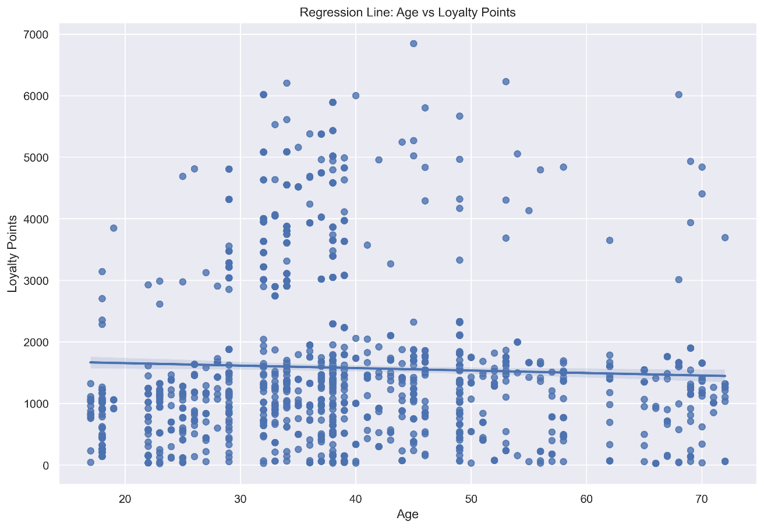

Salary vs Loyalty Points (Linear Regression)
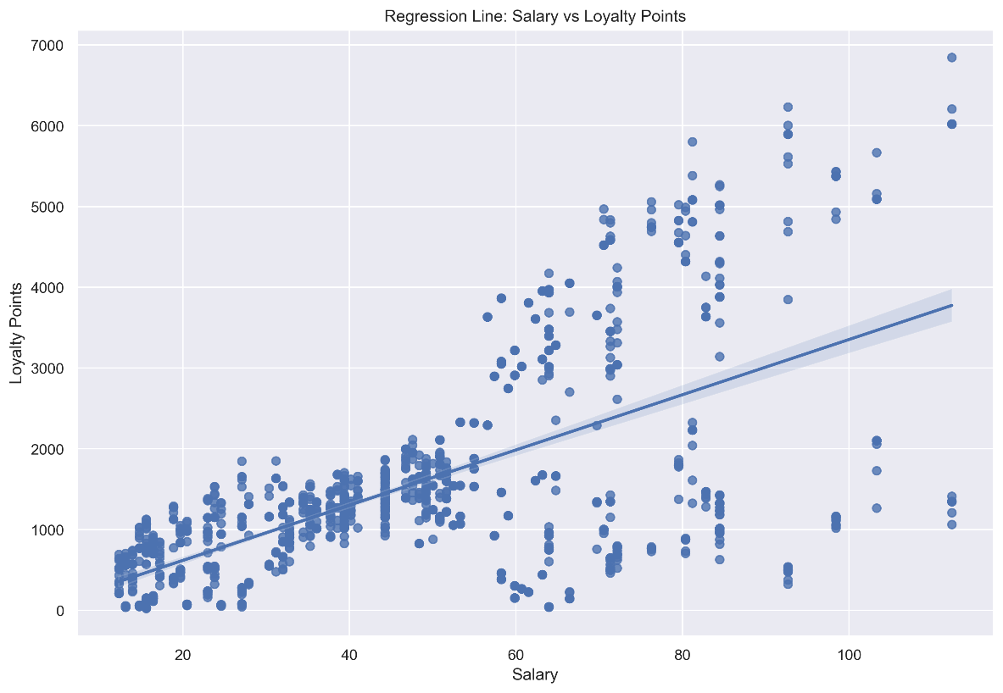

Spending score vs Loyalty Points (Linear Regression)
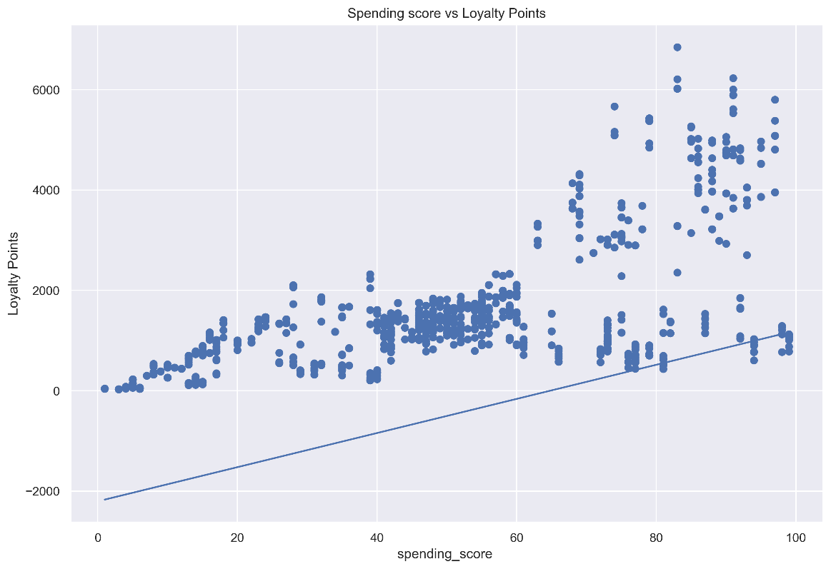

Age, salary and spending score all positively influence loyalty points. Salary and spending score have the strongest impact (coefficient 34), while age is less influential (coefficient 11).

Decision Tree
A decision tree shows how customer attributes influence loyalty points. Spending score is the most important factor.

Clustering with k-means using Python
K-means clustering identifies customer segments.

k-means clustering results

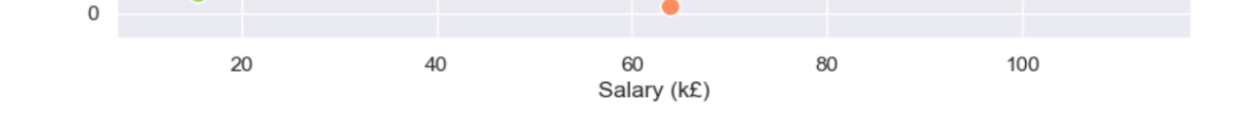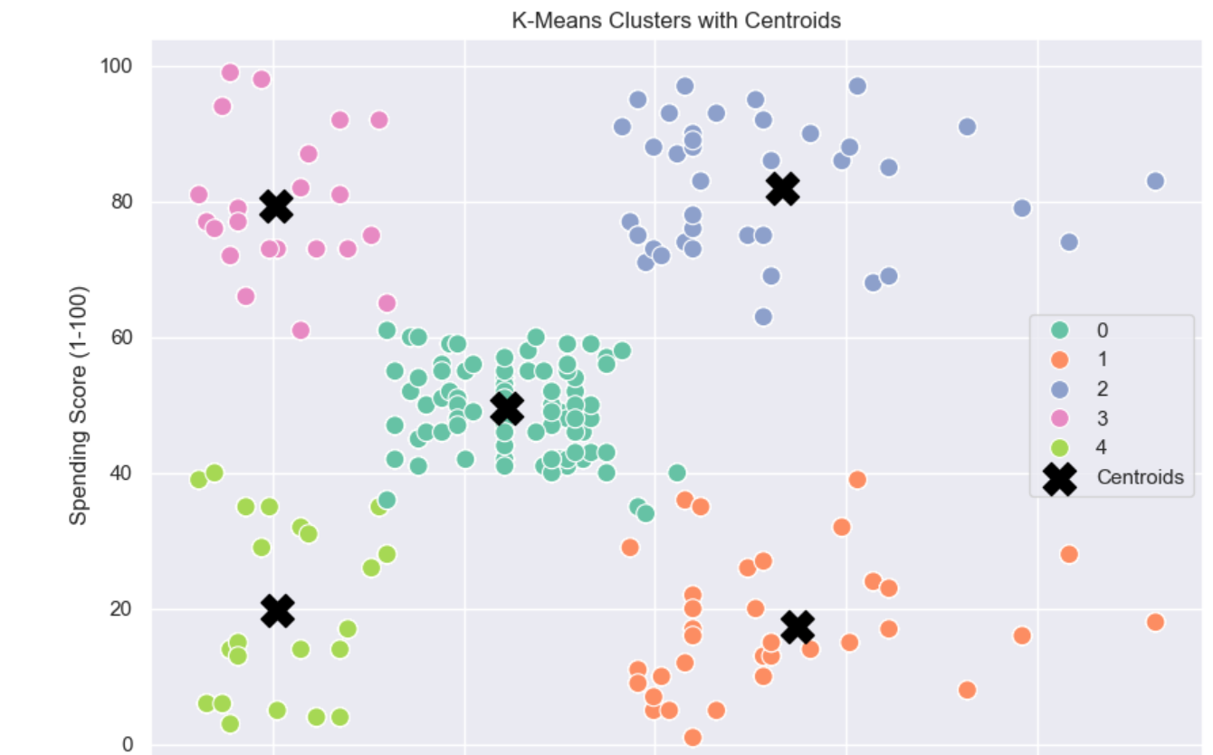
Five clusters were optimal using elbow and silhouette methods. Customer segments can be targeted for personalised offers and marketing strategies
1 Low salary, low spenders
Budget conscious customers
2 Low salary, high spenders
Impulse buying
3 Mid income, mid spenders
Proportional spend to salary
4 High Income, low Spenders
Cautious spenders or savers
5 High Income, high spenders
Premium customers
Natural Language Processing (NLP) using Python
NLP converts customer reviews into measurable insights. Sentiment plots show proportions of positive, negative and neutral reviews and word maps to visualise word frequency,
NLP identified common themes such as game related terms and generally positive sentiment, with few strongly negative reviews and some highly positive scores.
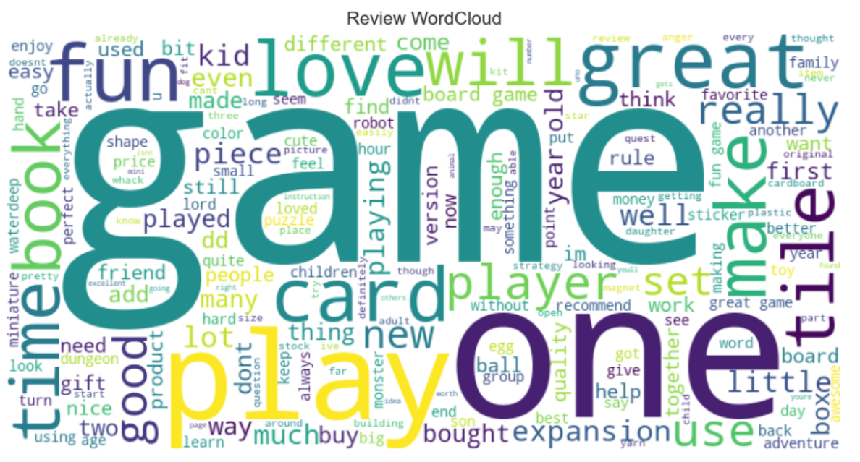
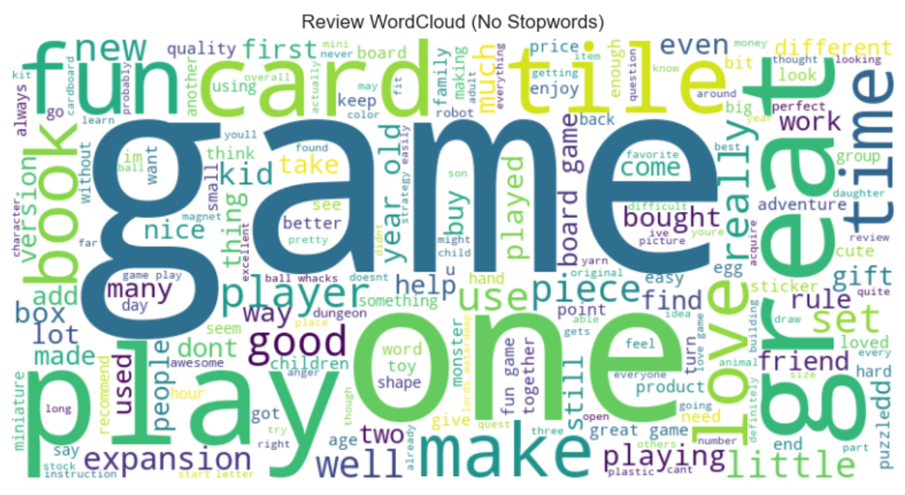
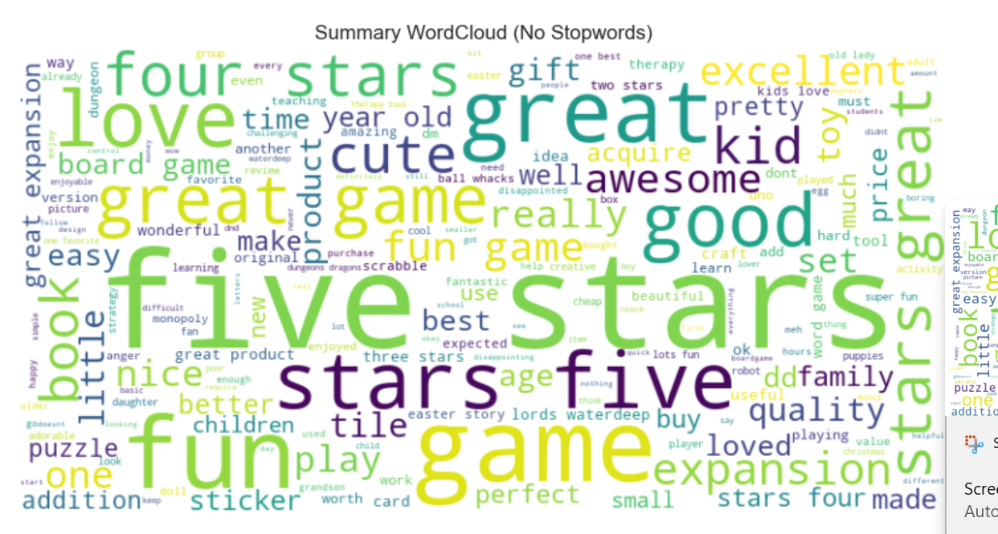
Sentiment score vs frequency (Sentiment plot)
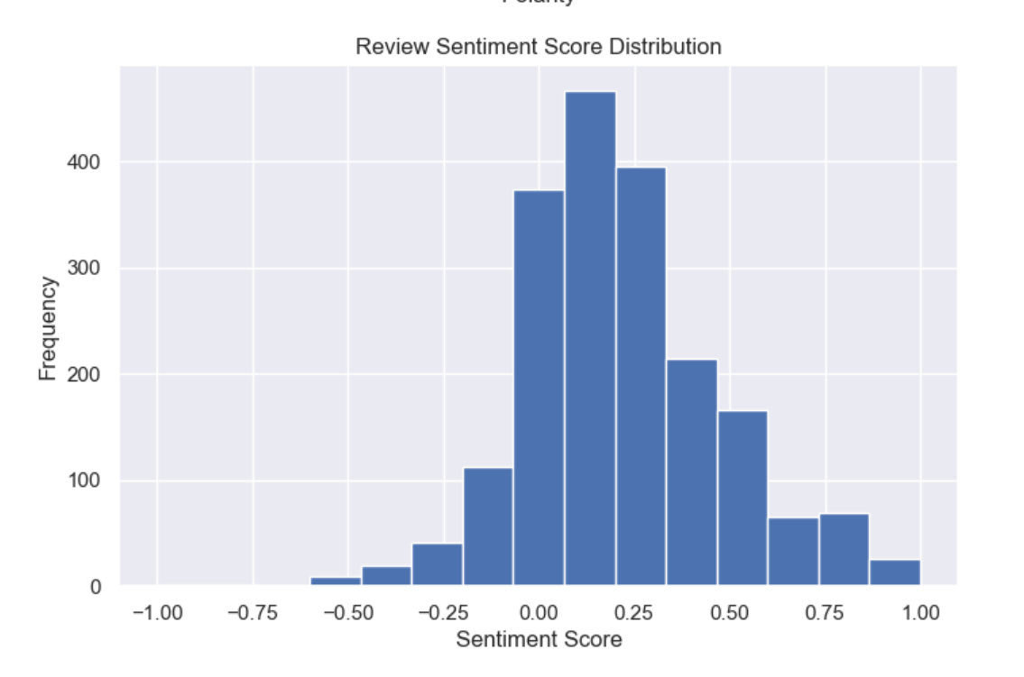

Histograms
Histograms show distribution of one variable, loyalty points. Positive skew is shown, with most customers having relatively low loyalty points and a small number of customers showing very high loyalty, indicating a small high value customer segment.

Count of loyalty points (histogram)
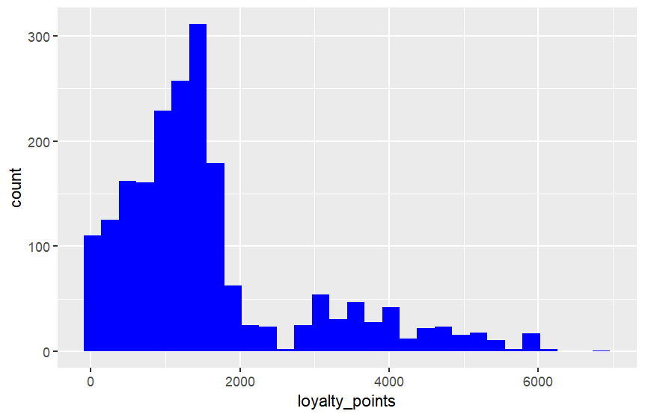

Scatterplots
Scatterplots show customer segments by salary and spending. They highlight high value and low engagement groups for targeted marketing.
Age
Age shows weak correlation with many outliers
Age vs loyalty points (scatterplot)

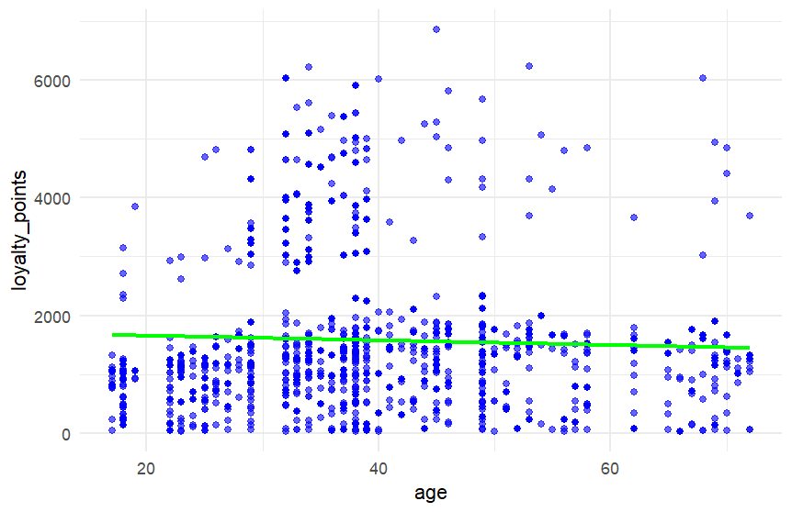
Salary
Salary shows a positive correlation with loyalty points.
Salary vs loyalty points (scatterplot)

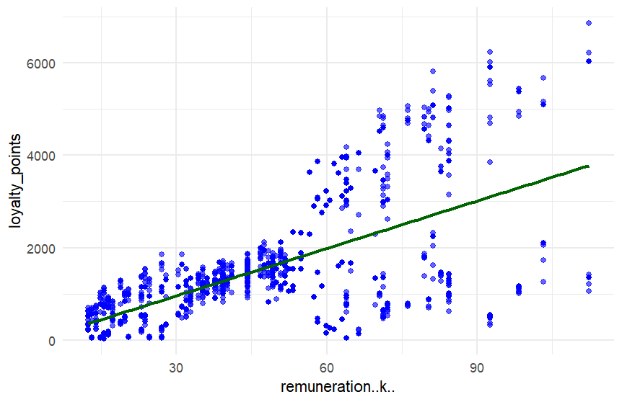
Boxplots
Boxplots show variance and outliers across different segments of the data. High spending shows greater variability and more outliers.
Spending score vs loyalty points (boxplot)

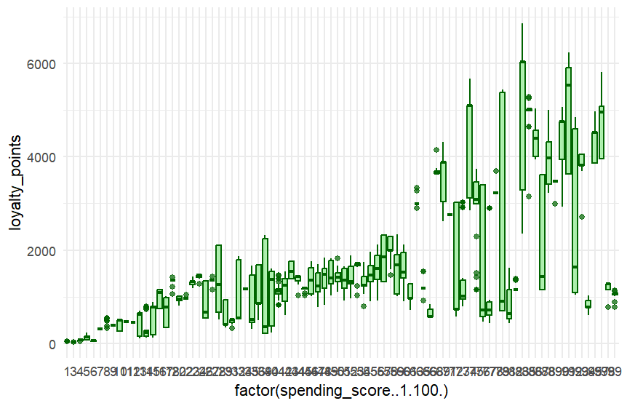
Multiple regression analysis

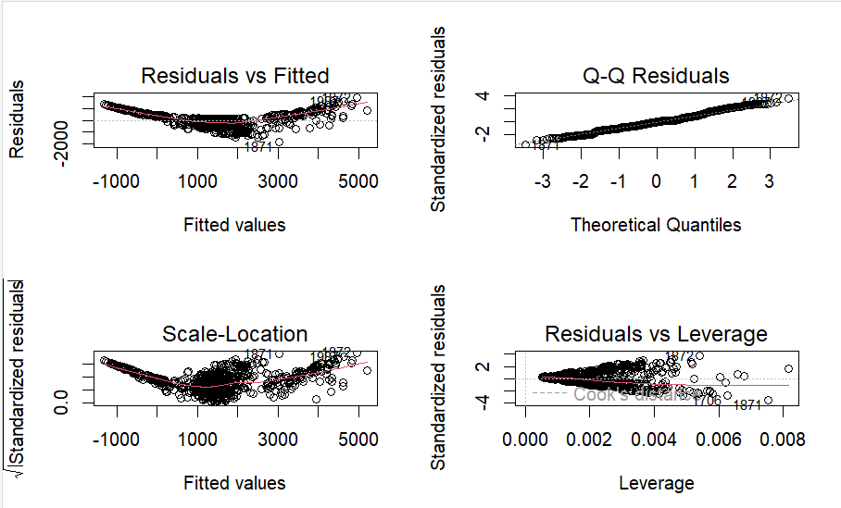

The diagnostic plots show the model fits well overall, but some assumptions are violated.
Variability and outliers, as highlighted in Boxplot, at high spending levels reduce accuracy. The residuals vs fitted plot suggests non linearity and the scale location plot shows increasing variance at higher values. The Q-Q plot is mostly normal but shows some outliers at the extremes. A few influential points are also present in the residuals vs leverage plot. Model accuracy is limited for high value customers due to non-linearity and heteroscedasticity.

- Patterns and predictions
Analysis of customer behaviour focused on how customers engage with and accumulate loyalty points, identifying meaningful segments for targeted marketing and using reviews to understand sentiment and preferences.
Loyalty points are positively influenced by age, salary and spending score, with salary and spending having the strongest impact. This indicates that higher income, high spending customers contribute most to loyalty engagement, although variability at higher spending levels suggests inconsistent rewards.
Customer segmentation revealed five key groups, including budget conscious, impulse buyers and high value customers. To enhance segmented marketing, further analysis of purchasing behaviour and social platform preferences would be valuable.
Sentiment analysis shows reviews are slightly positive, indicating general satisfaction but limited strong enthusiasm, suggesting opportunities to enhance the customer experience.
Recommendations prioritised by impact to improve loyalty and engagement -
High impact: Target high income, high spending customers with personalised rewards such as early access and exclusive discounts to maximise revenue from the most valuable segment with the aim to shift sentiment from neutral to strongly positive.
High impact: Use segmented marketing based on customer behaviour and further product consumption analysis such as promoting new video games via Instagram to high spenders, where this aligns with their purchasing and platform preferences.
Medium impact: Standardise loyalty programme through clear earning rules, tiered reward levels and milestone incentives to ensure consistency and fairness. This should be clearly communicated with all customers via email to promote spending, increase engagement and encourage repeat purchases.
Analysis improvement: Future improvements for multiple linear regression model could address non-linearity and heteroscedasticity through variable transformations, polynomial terms or robust standard errors. Model performance may also be enhanced by adding relevant predictors and further examining influential observations. Alternative modelling approaches and out of sample validation could improve predictive accuracy and generalisability.

Appendices

Appendices 1 : Python coding

Appendices 2 : R Studio coding
# Install once if needed
install.packages("tidyverse")

# Load libraries
library(tidyverse)

# Import data turtle_reviews.csv
turtle <- read.csv("turtle_reviews.csv", header = TRUE)

# View data
head(turtle)
str(turtle)
summary(turtle)

# Remove columns
turtle <- turtle %>%
select(language,platform)

turtle <- turtle %>%
rename(
salary = remuneration..k..,
spending = spending_score..1.100.
)

turtle %>%
group_by(loyalty_points) %>%
summarise(count = n())

names(turtle)

#plot histogram
ggplot(turtle, aes(x = loyalty_points))+
geom_histogram(fill = "blue")

#hiostogram for loyalty points and age DOESNT WORK
ggplot(turtle) +
geom_histogram(aes(x = loyalty_points, fill = "Loyalty Points"),
bins = 30, alpha = 0.5) +
geom_histogram(aes(x = age, fill = "Age"),
bins = 30, alpha = 0.5) +
scale_fill_manual(values = c("Loyalty Points" = "skyblue",
"Age" = "orange")) +

# scattergraph age
theme_minimal()

ggplot(turtle, aes(x = age, y = loyalty_points)) +
geom_point(color = "blue", alpha = 0.6) +
geom_smooth(method = "lm", color = "green", se = FALSE) +
theme_minimal()

#line of best fit
ggplot(turtle, aes(x = age, y = loyalty_points)) +
geom_point() +
geom_smooth(method = "lm")color = "darkgreen", se = FALSE) +
theme_minimal()

#plot scattergraph
ggplot(turtle, aes(x = remuneration..k.., y = loyalty_points)) +
geom_point(colour = "blue")

#line of best fit
ggplot(turtle, aes(x = remuneration..k.., y = loyalty_points)) +
geom_point() +
geom_smooth(method = "lm")color = "darkgreen", se = FALSE) +
theme_minimal()

#colour amended scattergraph
ggplot(turtle, aes(x = remuneration..k.., y = loyalty_points)) +
geom_point(color = "blue", alpha = 0.6) +
geom_smooth(method = "lm", color = "darkgreen", se = FALSE) +
theme_minimal()

#plot boxplot
ggplot(turtle, aes(x = factor(spending_score..1.100.), y = loyalty_points)) +
geom_boxplot()

#boxplot with colour
ggplot(turtle, aes(x = factor(spending_score..1.100.), y = loyalty_points)) +
geom_boxplot(fill = "lightgreen", color = "darkgreen", alpha = 0.7) +
theme_minimal()

# Install once if needed
install.packages("tidyverse")

# Load libraries
library(tidyverse)

# Load required libraries
library(tidyverse)

# Load your dataset
data <- read.csv("turtle_reviews.csv")

# View structure
str(data)
summary(data)

# Remove missing values
data <- na.omit(data)

# Ensure numeric variables are correct
data$age <- as.numeric(data$age)
data$salary <- as.numeric(data$salary)
data$spending_score <- as.numeric(data$spending_score)
data$loyalty_points <- as.numeric(data$loyalty_points)

# Correlation matrix
cor(data[, c("age", "remuneration..k..", "spending_score..1.100.", "loyalty_points")])

# Create model
mlr_model <- lm(loyalty_points ~ age + remuneration..k.. + spending_score..1.100., data = data)

# View model summary
summary(mlr_model)

# Diagnostic plots
par(mfrow = c(2, 2))
plot(mlr_model)

